Amrita Viswa Vidyapeetham
Amrita School of Engineering
Dept of Computer Science & Engineering

19CSE301 Computer Networks Lab
Lab Sheet 1 - Analyzing http using Wireshark

- Open Packet sniffer [Wireshark] Application and Capture YOUR NETWORK Interface
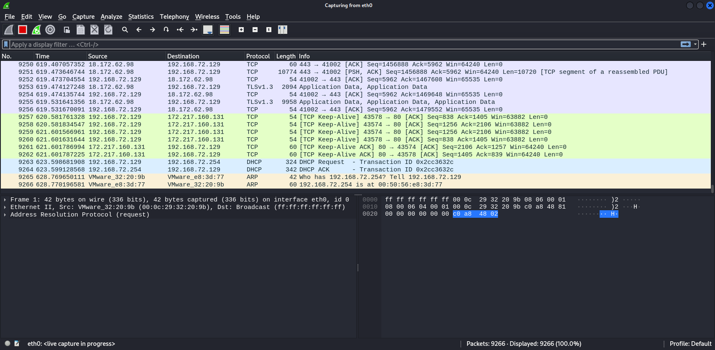
- Do this activity and capture frames?
  - Request for a web page from amrita.edu and search for some keyword in the webpage
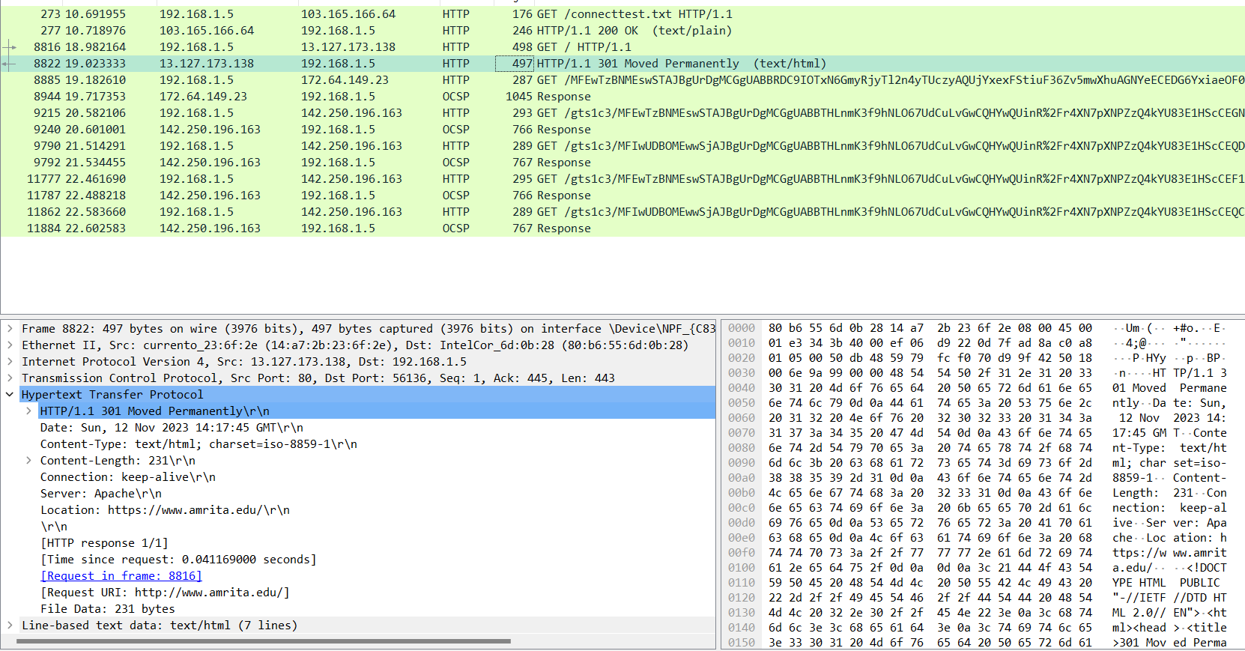
  - Open some URL (in which you can post some comments) in your browser and post a comment in it.
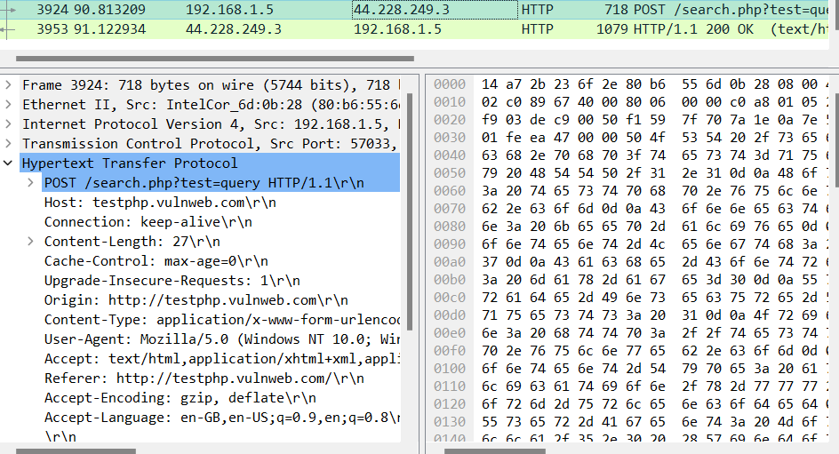
- Explain the working of the HTTP protocol [HTTP GET and POST message] briefly with typed answers and answer highlighted screenshots for the above activity from Wireshark.

HTTP GET : Is used to fetch an object from a server, such as html, php, jpeg, png, etc files.
HTTP POST:Is used to give information to a server, such as password, etc.

  - Analyze the sender and destination IP address, Port address and Physical address (Proxy Server)

Sender : Is my local IP address not my public one
Destination : Is the server’s IP address
Port Address: Is 80 for http and 443 for https
Physical address: for example => example.com
Here is the IPv4 and IPv6 address
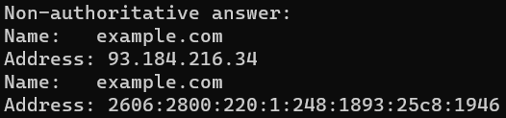

  - Analyze the Host machine and webpage name in the file server
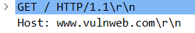
  - Check the acknowledgement frame for successful request and the unsuccessful request
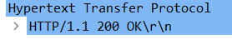
  - Analyze how the uploaded data has reached the server
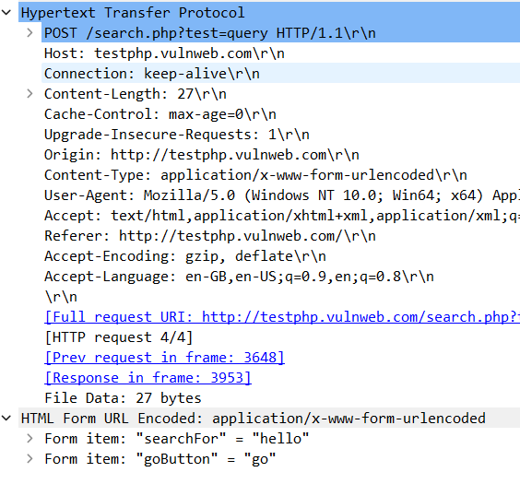
  - Find the following from frames received for the above activity
    - Is your browser running HTTP version 1.0 or 1.1?
1.1
What version of HTTP is the server running?
1.1
    - What languages (if any) does your browser indicate that it can accept to the server?
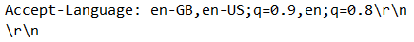
    - What is the status code returned from the server to your browser?
    - When the HTML file that you are retrieving was last modified at the server?
    - How many bytes of content are being returned to your browser?
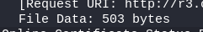
    - By inspecting the raw data in the packet content window, do you see any headers within the data that are not displayed in the packet-listing window? If so, name one.
No
    - Can you tell whether your browser downloaded the two images serially, or whether they were downloaded from the two web sites in parallel? Explain.
Parallelly downloaded
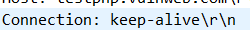
Connection was not closed.
    - What is the server’s response (status code and phrase) in response to the initial HTTP GET message from your browser?

- Open AUMS and download a file. Stop capture. Using statistics tools find the time taken for downloading the file.
2 sec
- Open your sharepoint page(URL in Q2) and download a video file. Find the number of routing endpoints visited and the switches visited. Find the packet length transmitted and received, give the protocol hierarchy and the Flow graph

- Capture the frames for the following commands in the command prompt. printf "GET /HTTP/1.0\r\n" | nc ac.amrita.ac.in 80
Start up your web browser, and make sure your browser’s cache is cleared. Do this activity and capture frames
- Start up your web browser, and make sure your browser’s cache is cleared. Do this activity and capture frames
  - Enter the following URL into your browser “http://ac.amrita.ac.in”
  - Quickly enter the same URL into your browser again (or simply select the refresh button on your browser)
  - Stop Wireshark packet capture, and enter “http” in the display-filter-specification window, so that only captured HTTP messages will be displayed later in the packet listing window.
  - Answer the following questions:
  - Inspect the contents of the first HTTP GET request from your browser to the server. Do you see an “IF-MODIFIED-SINCE” line in the HTTP GET request
  - Inspect the contents of the server response. Did the server explicitly return the contents of the file? How can you tell?
  - Now inspect the contents of the second HTTP GET request from your browser to the server. Do you see an “IF-MODIFIED-SINCE:” line in the HTTP GET? If so, what information follows the “IF-MODIFIED-SINCE:” header?
  - What is the HTTP status code and phrase returned from the server in response to this second HTTP GET? Did the server explicitly return the contents of the file? Explain.
  - How many HTTP GET request messages were sent by your browser?
  - How many data-containing TCP segments were needed to carry the single HTTP response? What are the size for each of the segment?
  - What is the status code and phrase associated with the response to the HTTP GET request?

